



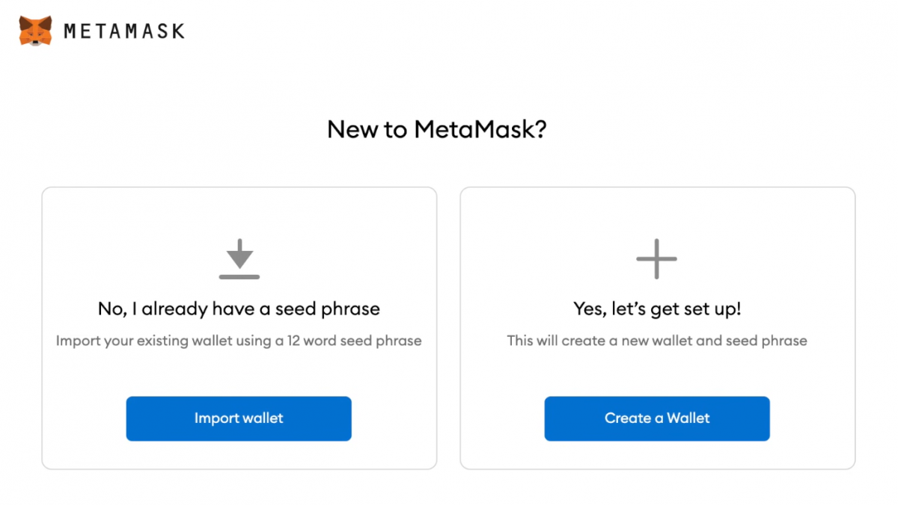

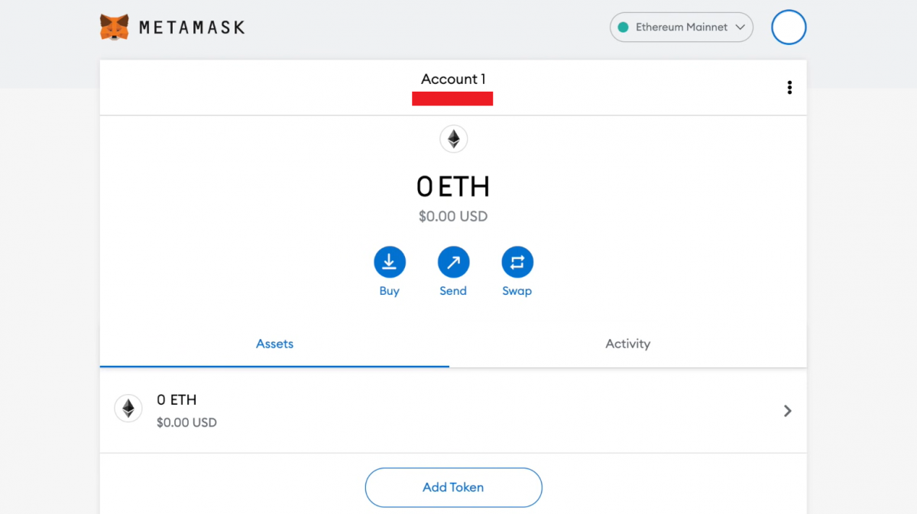

Per Ether Transaction Gas fee

Sender: Account 3

Receiver: demo

Function Type: Sending Ethereum

Transaction Data format: Hexadecimal encrypted bytes

Each transaction require some gas fee as well as the amount for the required amount of Ethereum being transferred.

